**Task: 1**

**Declaring the Integer, float and character variables.**

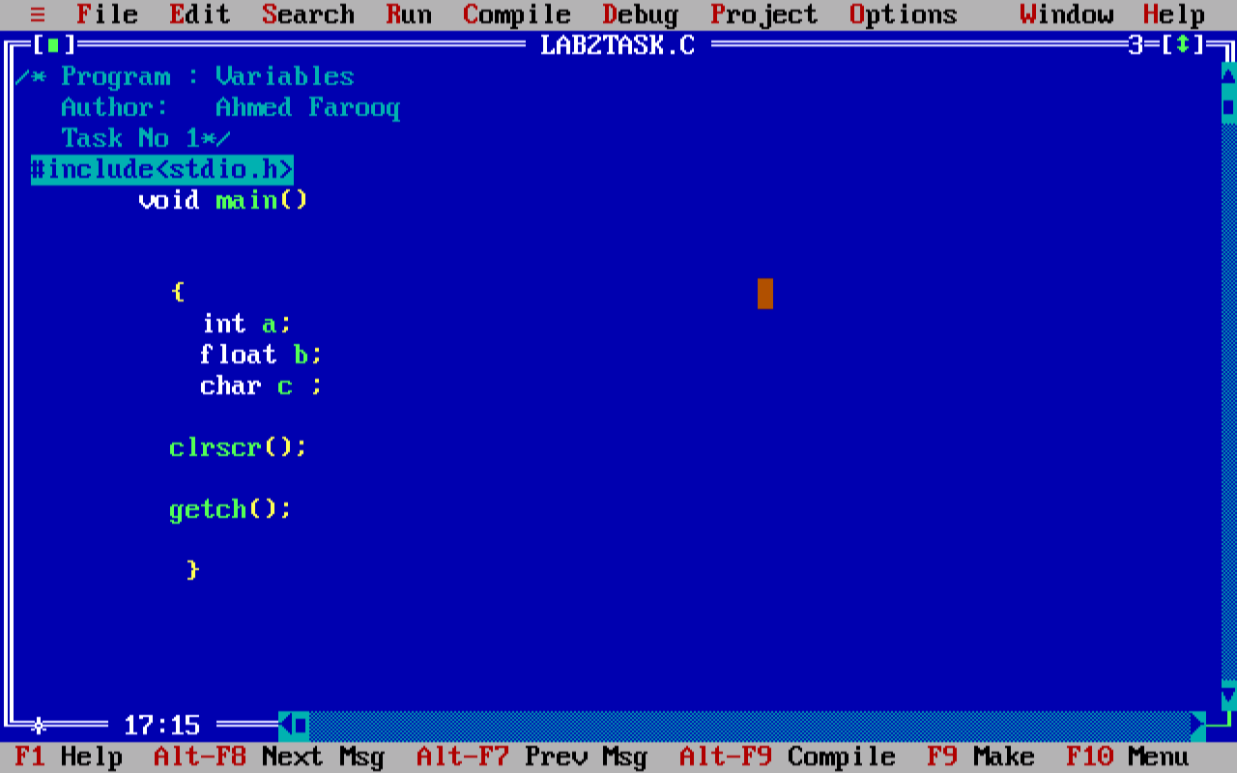

In the above code, I declare the integer (a), float (b) and character (c).

**Task: 2**

**Assigning the values to integer, float and character we declared.**

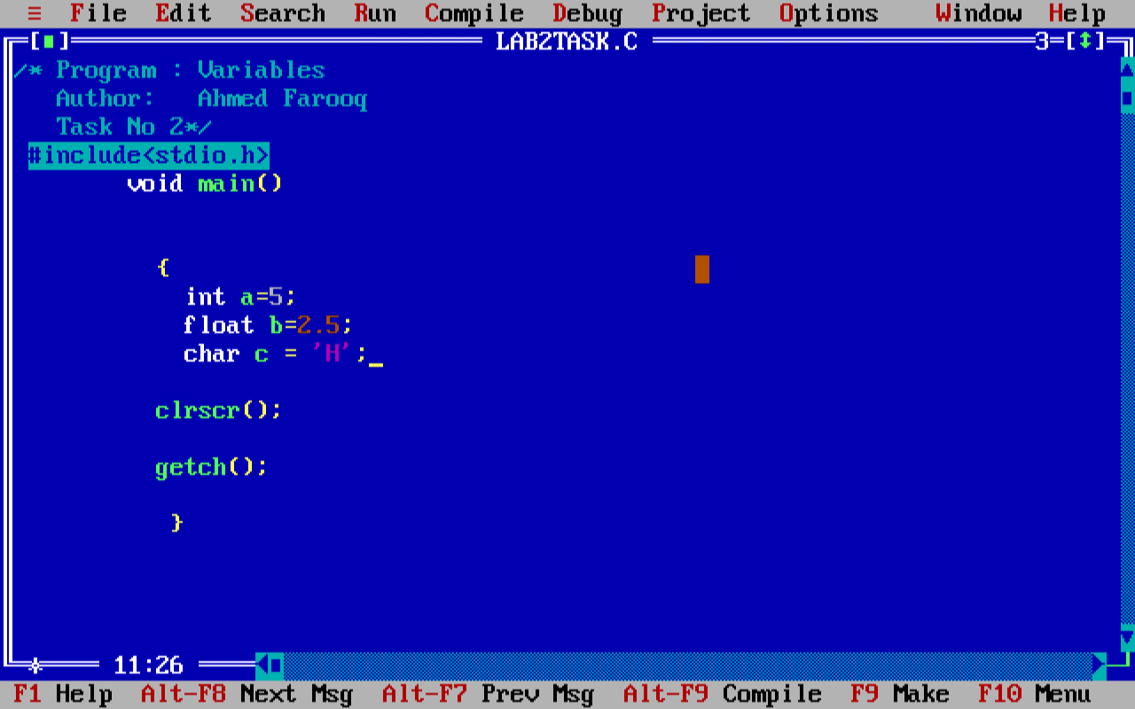

I have assign 5 to integer (a), 2.5 to float(b) and H to character to (c).

**Task: 3**

**Displaying the output using printf().**

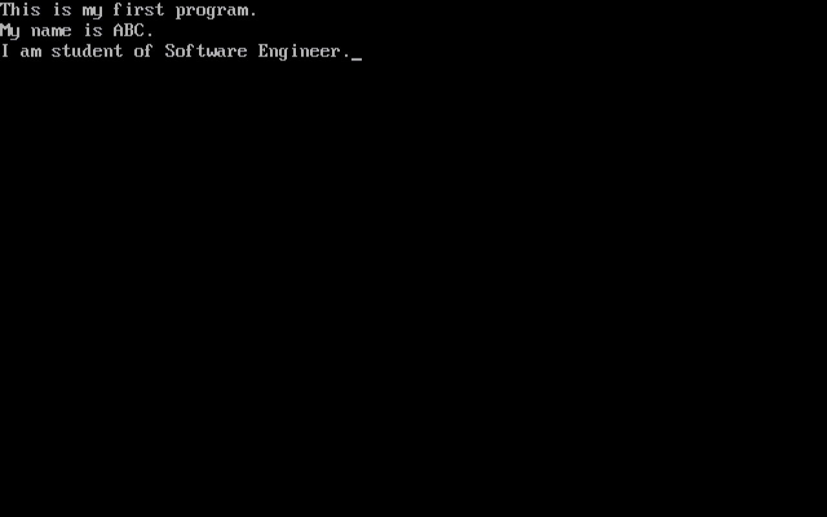

I showed the output as per the requirement of the lab task.

**Task: 4**

**Writing the program to show the required output.**

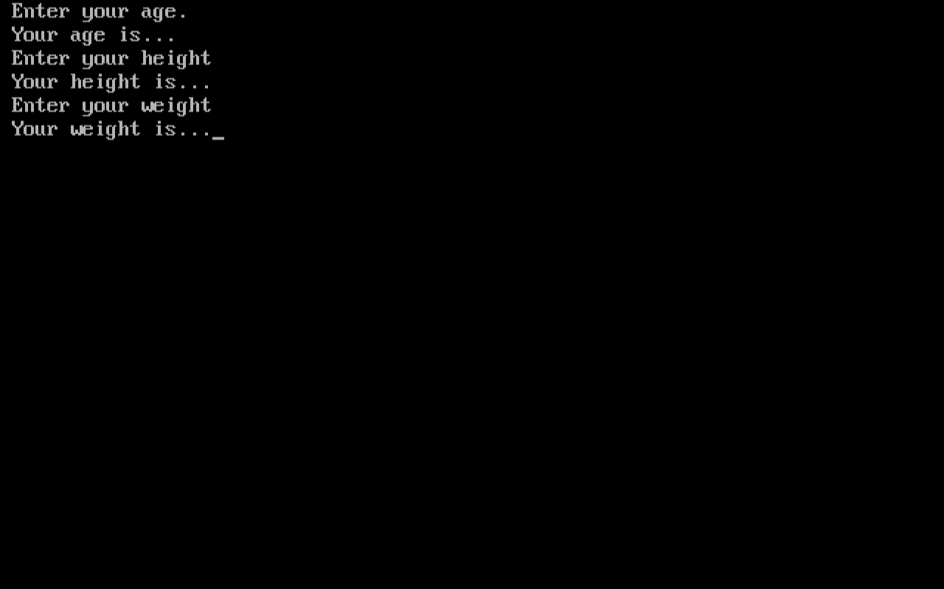

I showed the required output as per the requirement of the task.

**Task: 5**

**Writing the program to show the required output.**

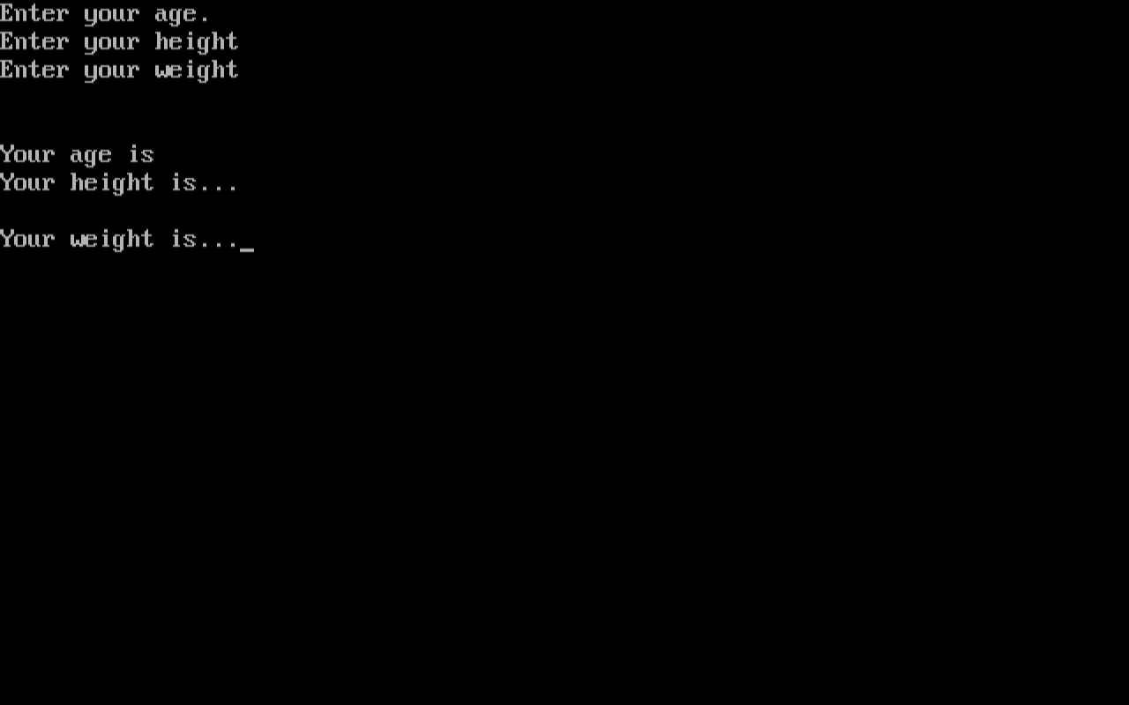

**Task: 6**

**Receive an int value from the user using scanf() store it in a variables and display it.**





In the above program, I received the integer from the user and stored it in the variable and also displayed it on the console screen.

**Task: 7**

**Receive an int and float value from the user using scanf() store it in a variables and display it.**



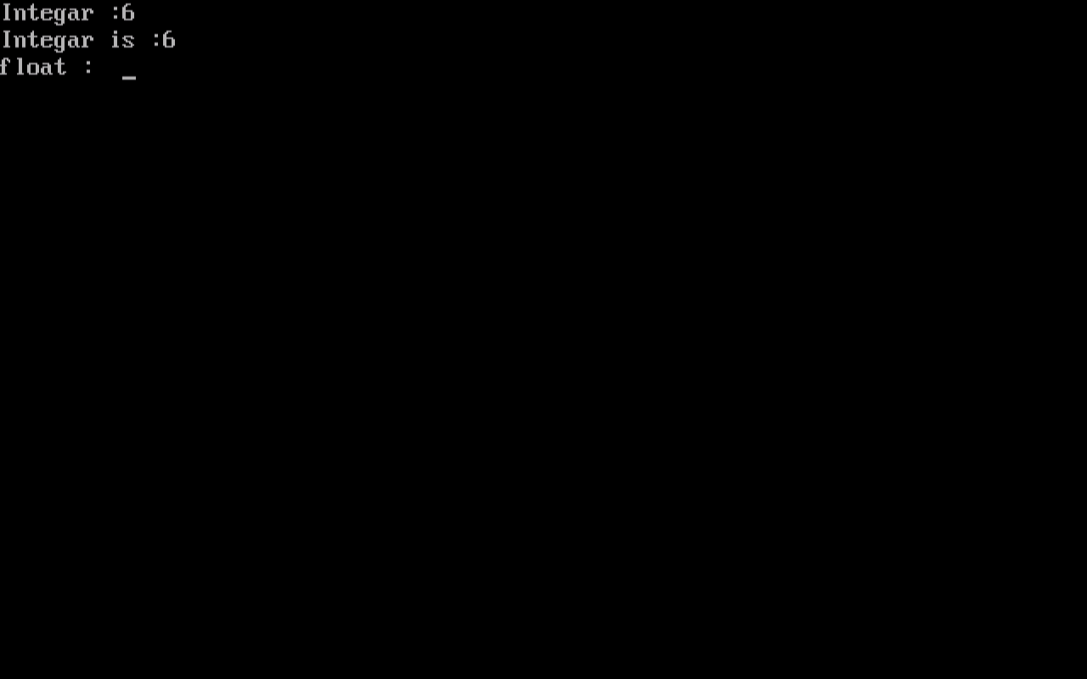

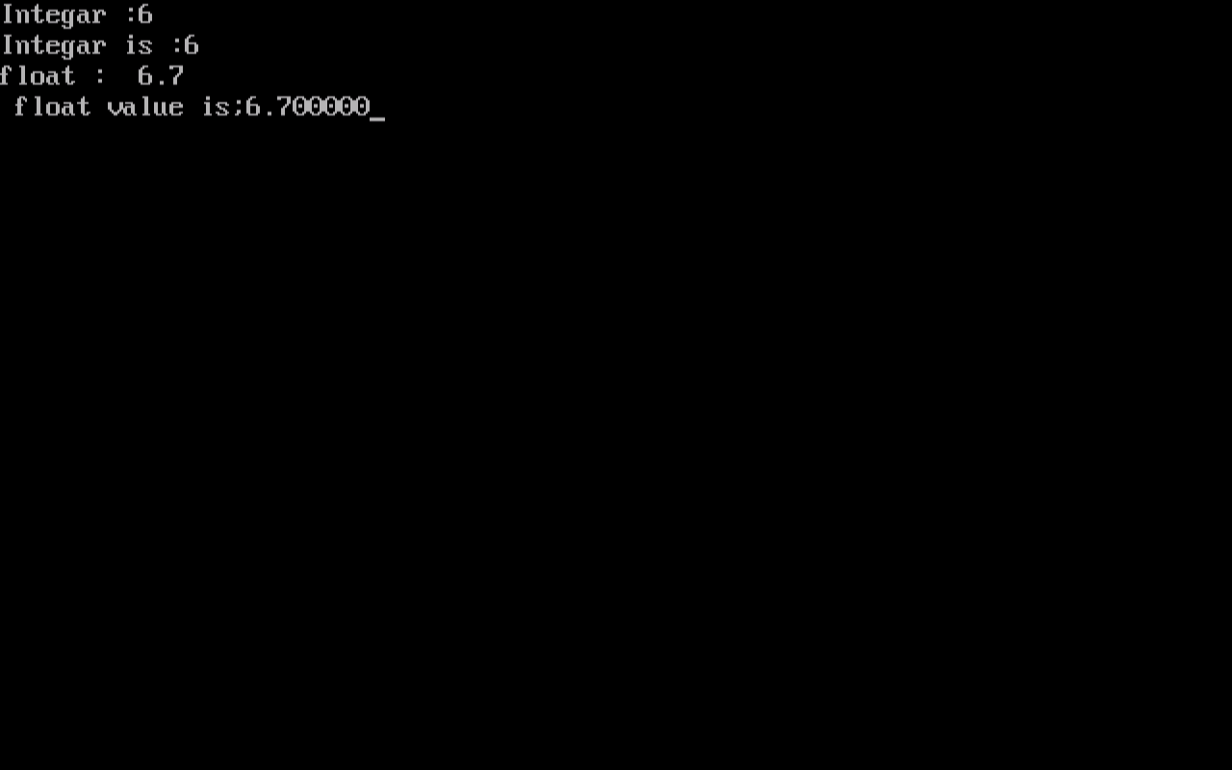

In the above program, I received the integer and float from the user and stored it in the variable and also displayed it on the console screen.

**Task: 8**

**Receive character value from the user and display it on the console screen**

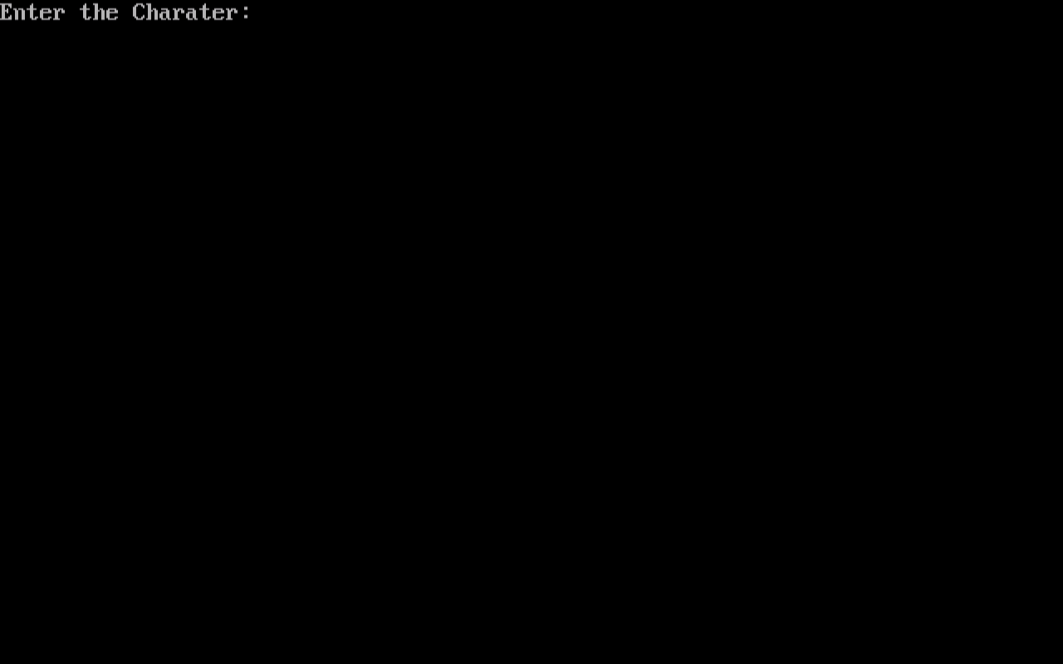

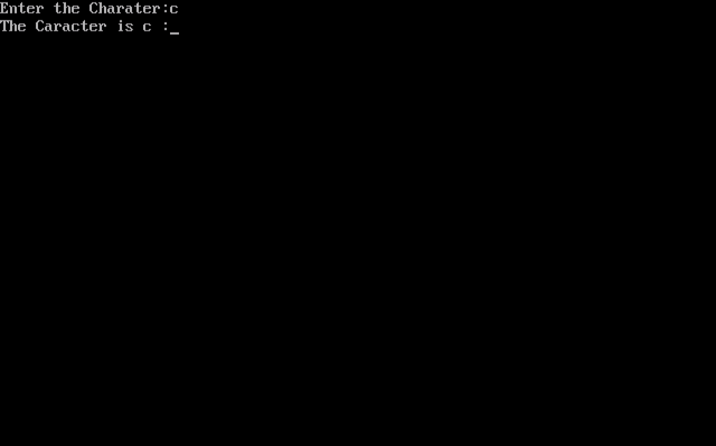

In the above program, I received the character value from the user and stored it in the variable and also displayed it on the console screen.